STEP 1: acess the easychair system: https://easychair.org

- Click Login (if you already have an easychair account)
- Click Signup (if you have not yet an easychair account):
+ This will take you to a new web page. Type the two words that you see in the image and click on "Continue". If you type the words correctly you will be asked to fill out a simple form with your personal information.
+ After submitting the form, EasyChair will send you an email with a link to create an account.
+ You will now be able to log-in easychair System

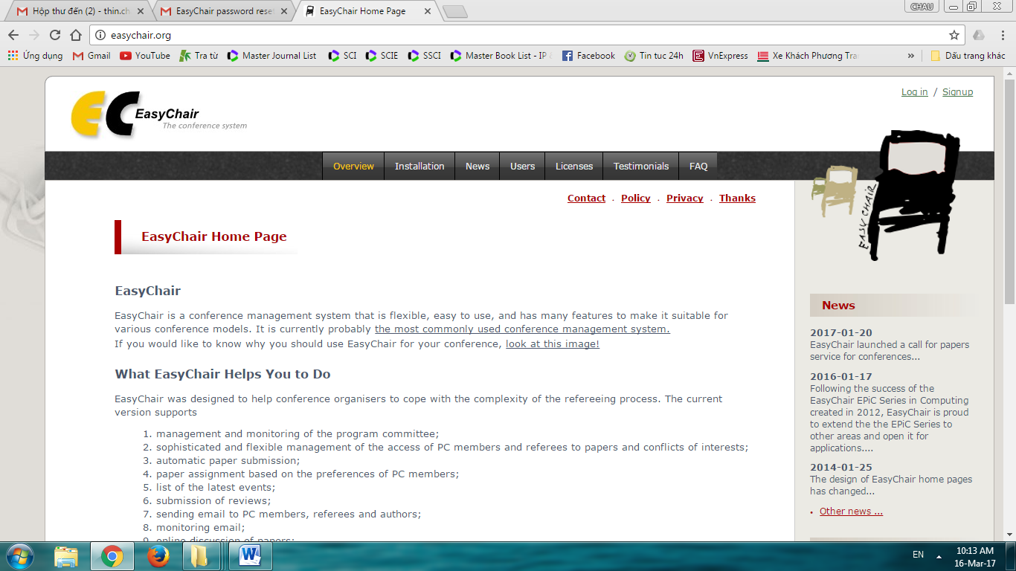

After Login, you will see interface of system as photo’s been shown below:

Next step:
v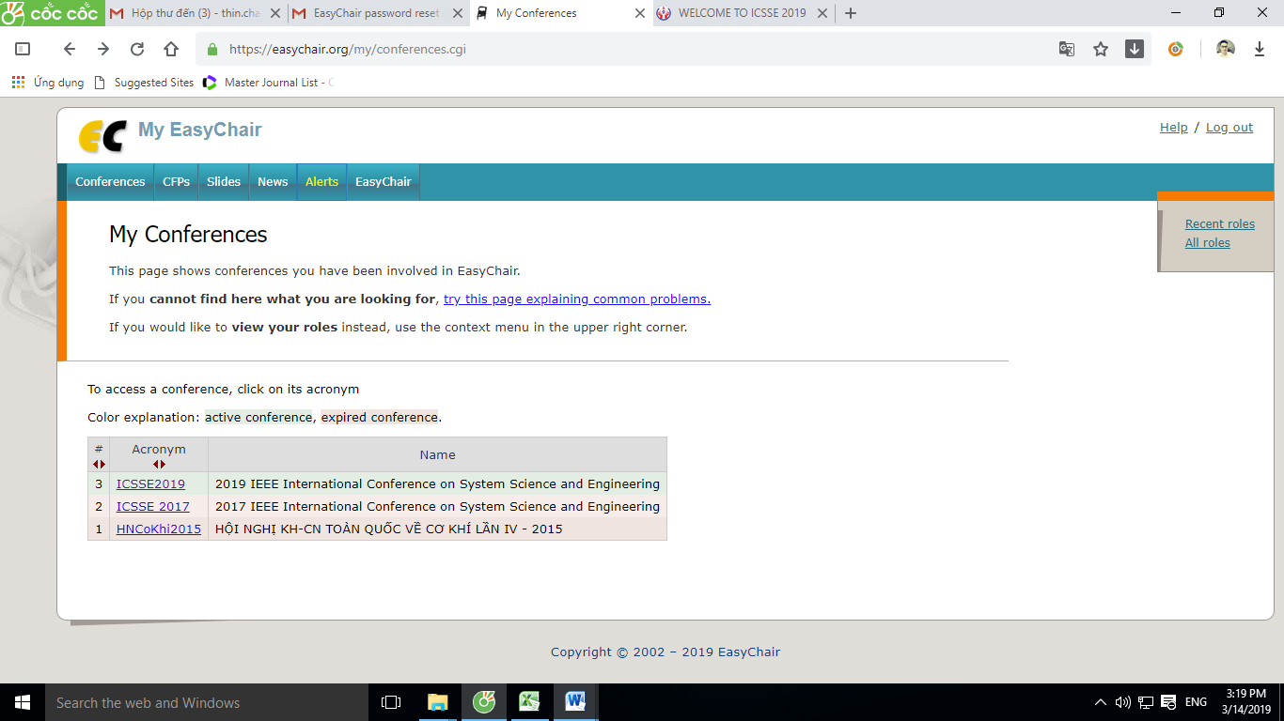
Click “Conference”
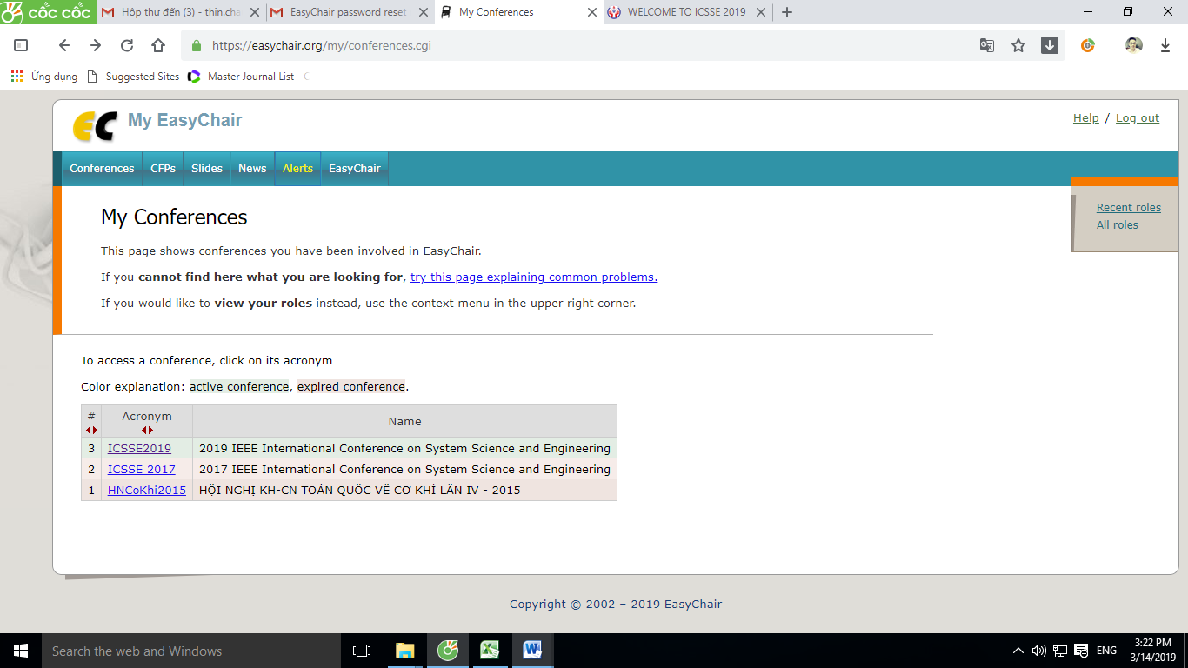
Click to choose conference. Example: you choose ICSSE2019

Next step:

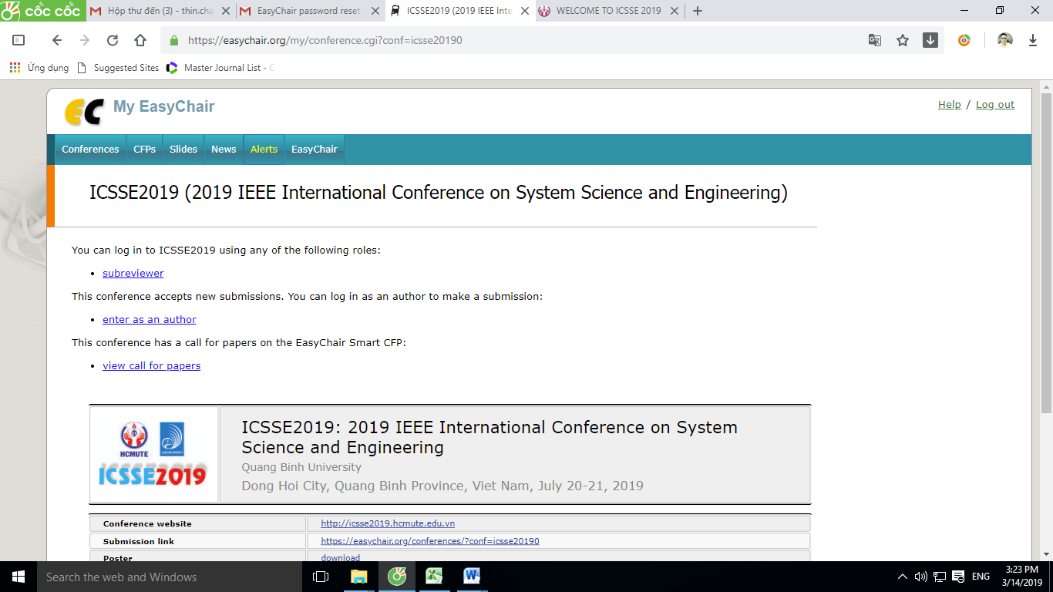
Click Subreviewer

Next step:

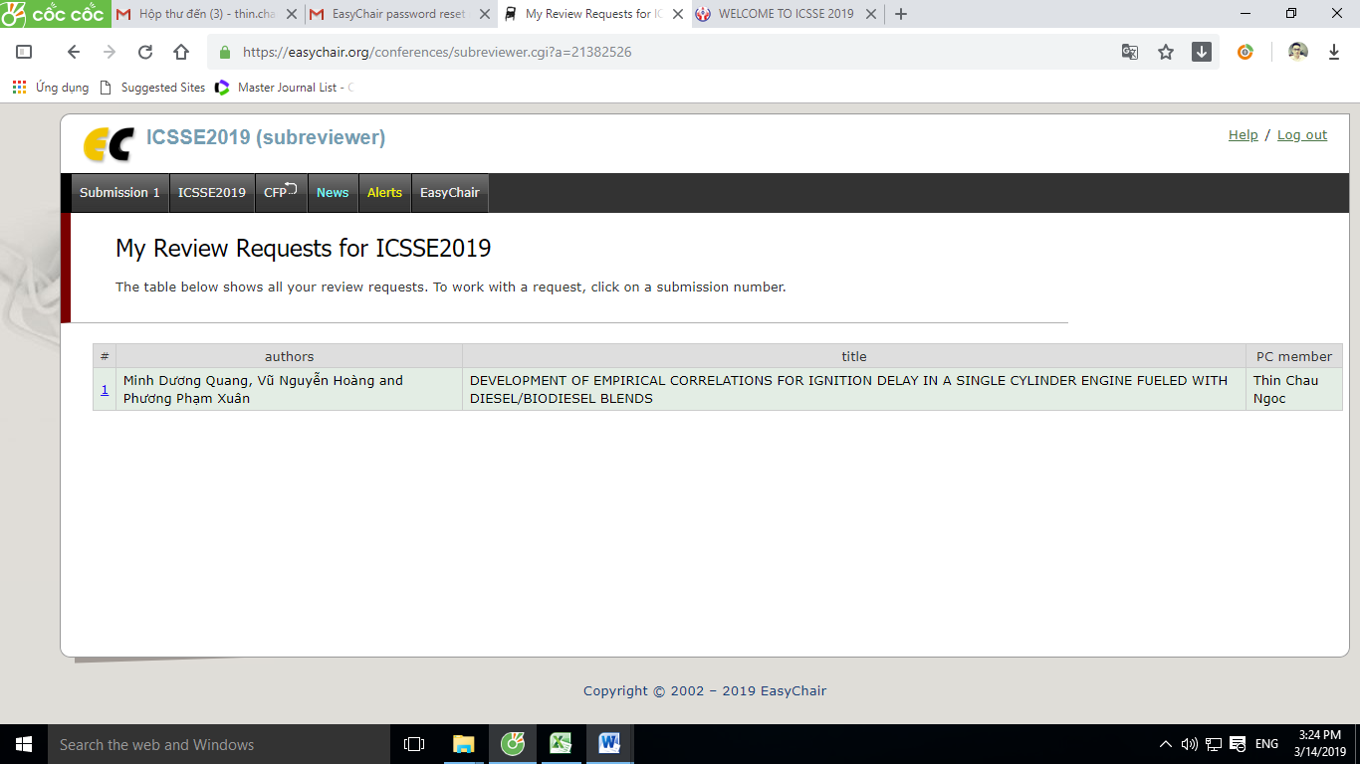
Click the ID of paper.

Next step:
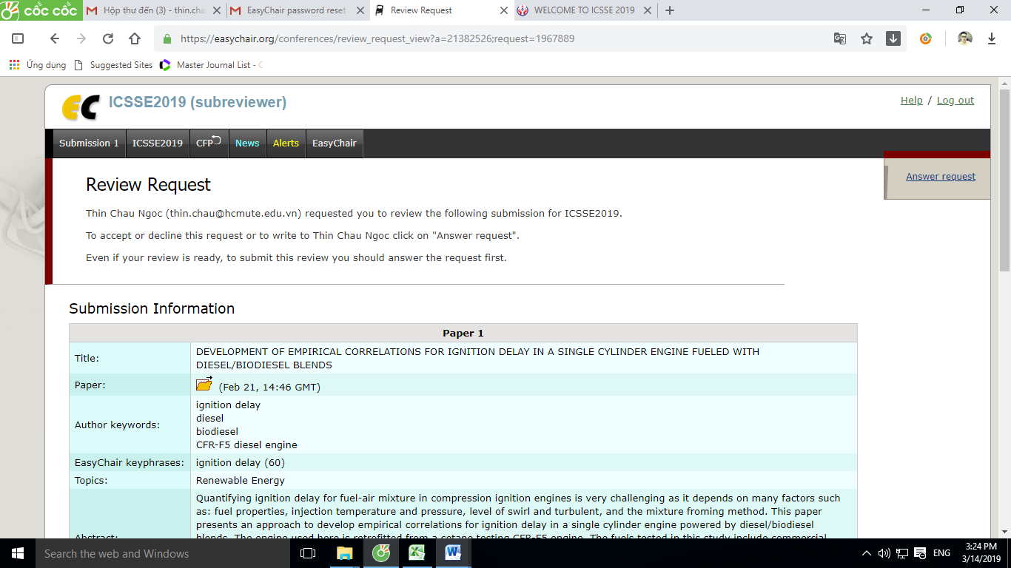
Click here to download Full paper
Click here to answer review request from program committee

Next step:
After you click “Answer request”, if you :
- Agree to review: in this case you should select "I agree to review this submission". The message is optional.
- Not agree to review: In this case you should select "I do not agree". The message is optional, however, you may think of suggesting names and email of other potential reviewers.
- Postpone your decision: Select "I will decide later".

Then click the red button “Select and/or send message”

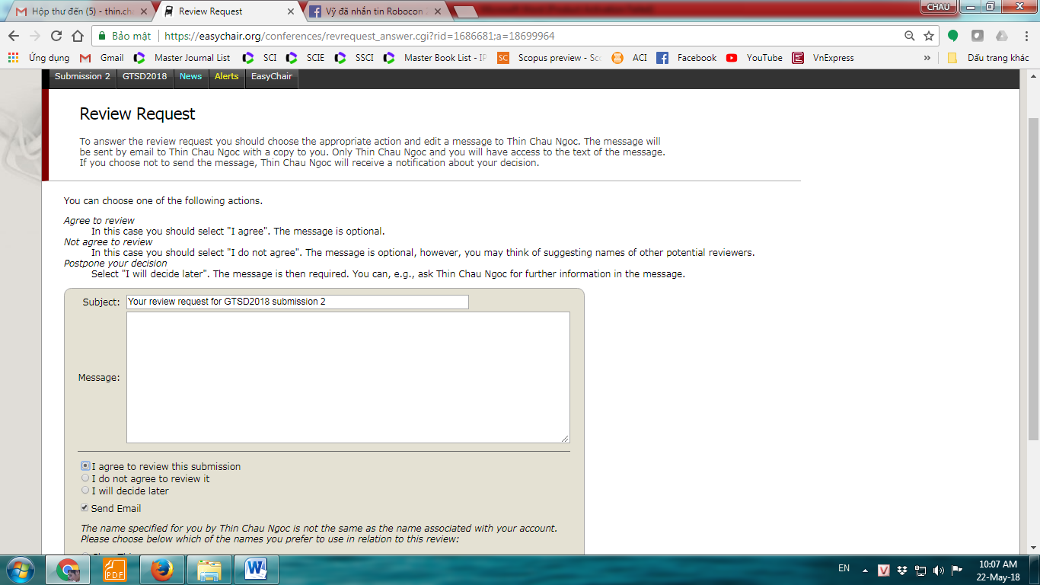
Write text here. Example: I agree review this paper./ I suggest some people who can review this paper ….

Next step: (after you selected: “I agree to review this submission”)

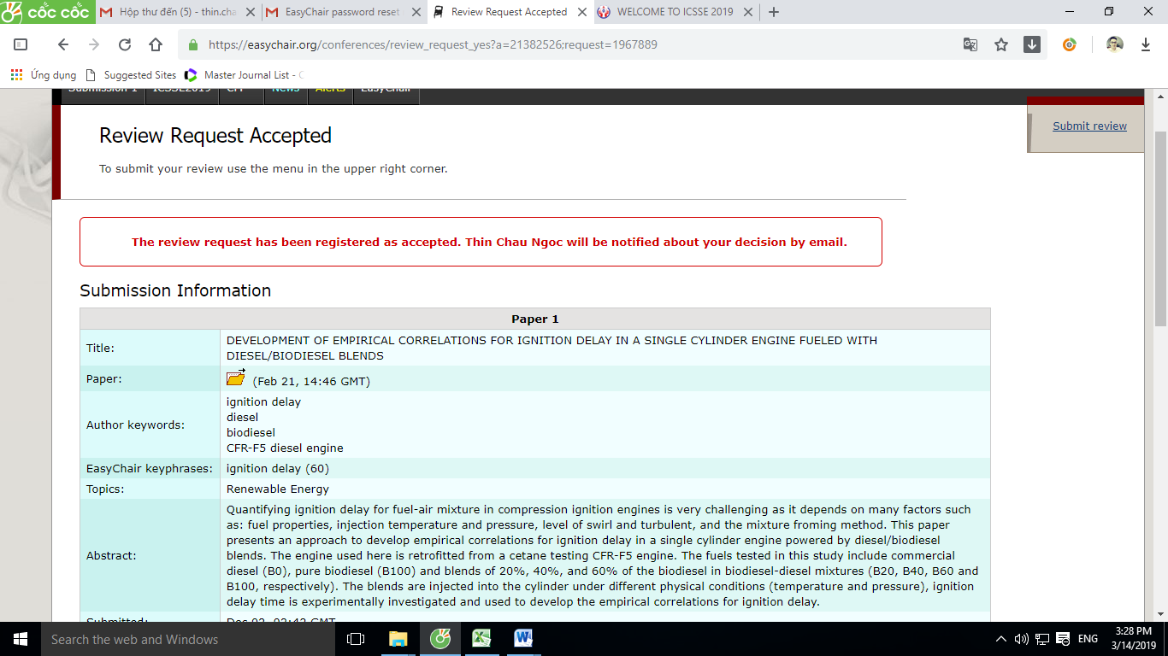
Click “Submit review” to fill out your evaluation. You should use the below review form to write your comment for the paper, after that you copy your comments to the form on Easychair.

Next step: Evaluate this submission
Tip: You should use the below review form (see page 7) to write your comments for the paper, after that you copy your comments to submit review on Easychair.

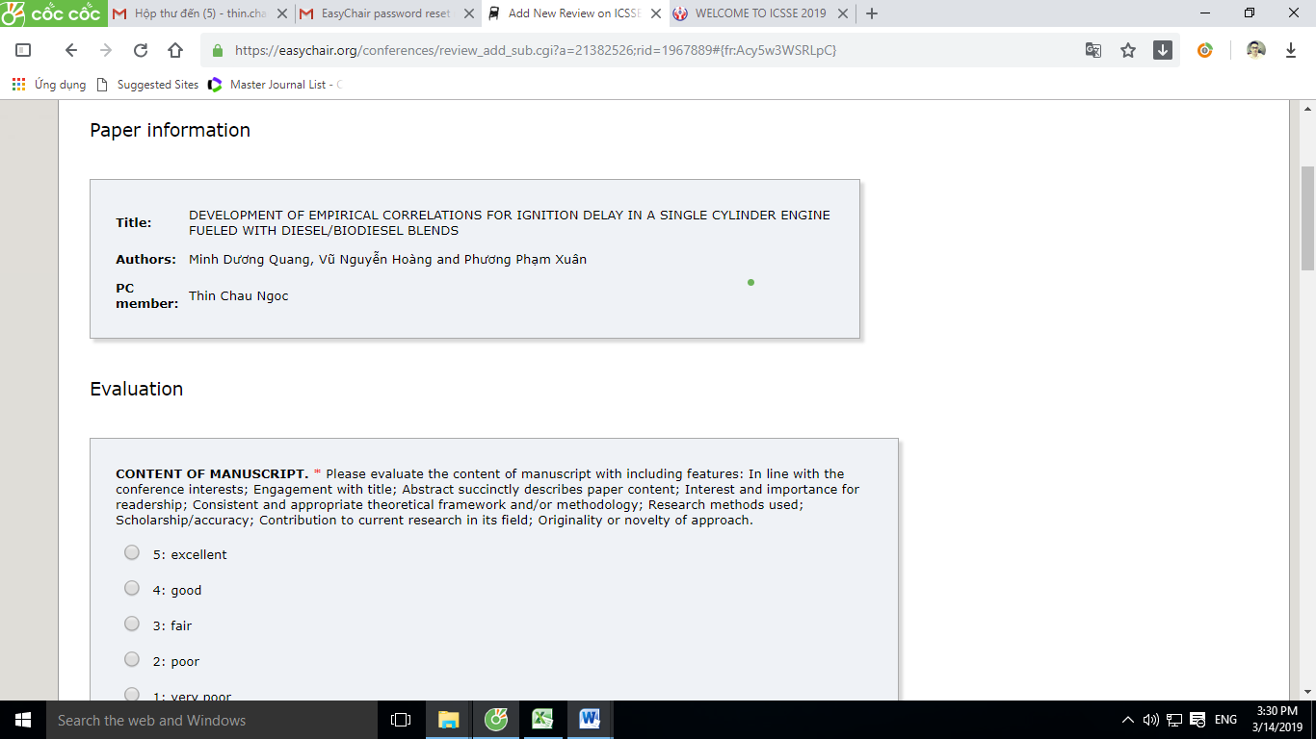

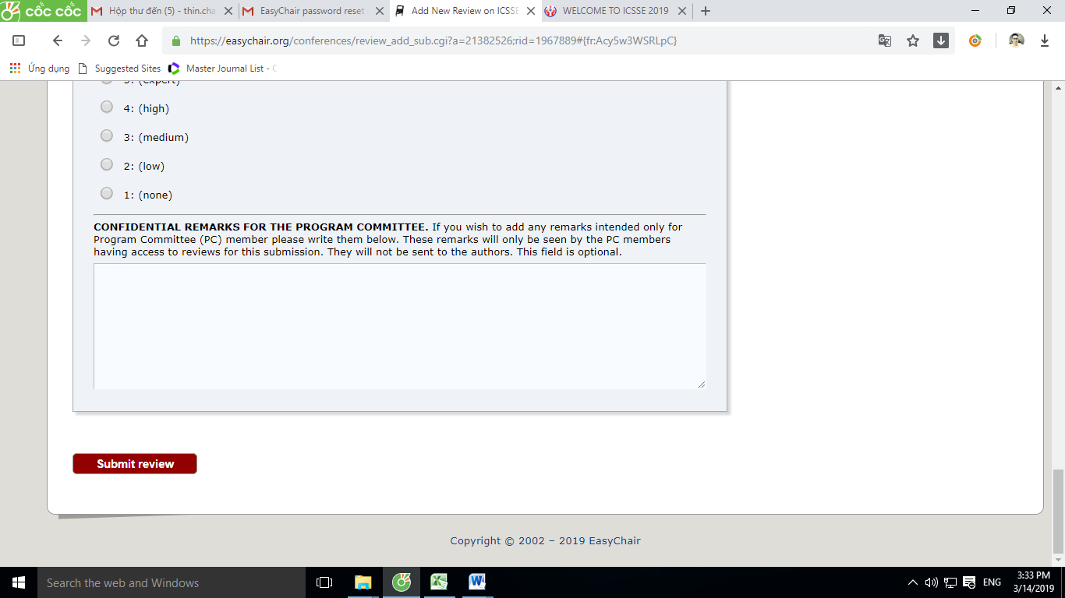
Click here after you have done the paper evaluation.

DONE!

ICSSE2019 REVIEWER FEEDBACK FORM

Paper ID
Paper Title

EVALUATION

CONTENT OF MANUSCRIPT (*). Please evaluate the content of manuscript with including features: In line with the conference interests; Engagement with title; Abstract succinctly describes paper content; Interest and importance for readership; Consistent and appropriate theoretical framework and/or methodology; Research methods used; Scholarship/accuracy; Contribution to current research in its field; Originality or novelty of approach.
1 | 2 | 3 | 4 | 5
very poor | poor | fair | good | excellent
Write your Comment here:

STYLE (*). Please evaluate manuscript with including features: Quality of writing; Paragraph and sentence structure; Appropriate phrasing and grammar.
1 | 2 | 3 | 4 | 5
very poor | poor | fair | good | excellent
Write your Comment here:

PRESENTATION (*). Please evaluate manuscript with including features: Referencing and bibliographic material; IEEE Formatting; Spelling and Punctuation; Legibility of figures and photos; Appropriateness of figures and photos; Presentation of empirical data (where applicable).
1 | 2 | 3 | 4 | 5
very poor | poor | fair | good | excellent
Write your Comment here:

OVERALL EVALUATION (*).Please provide a detailed review (The reviewer notes author here the mistakes, erros, typos... that author must be revised to improve the quality of this full paper to satisfy the committee), including a justification for your scores. Both the score and the review text are required.
-3 | -2 | -1 | 0 | 1 | 2 | 3
strong reject | reject | weak reject | borderline paper | weak accept | accept | strong accept

REVIEWER'S CONFIDENCE (*). Your confidence about this manuscript's field
1 | 2 | 3 | 4 | 5
none | low | medium | high | expert

CONFIDENTIAL REMARKS FOR THE PROGRAM COMMITTEE. If you wish to add any remarks intended only for PC members please write them below. These remarks will only be seen by the PC members having access to reviews for this submission. They will not be sent to the authors. This field is optional.

